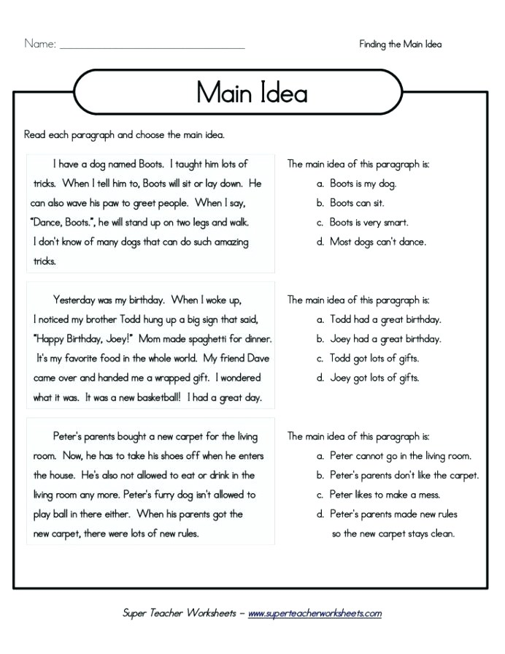
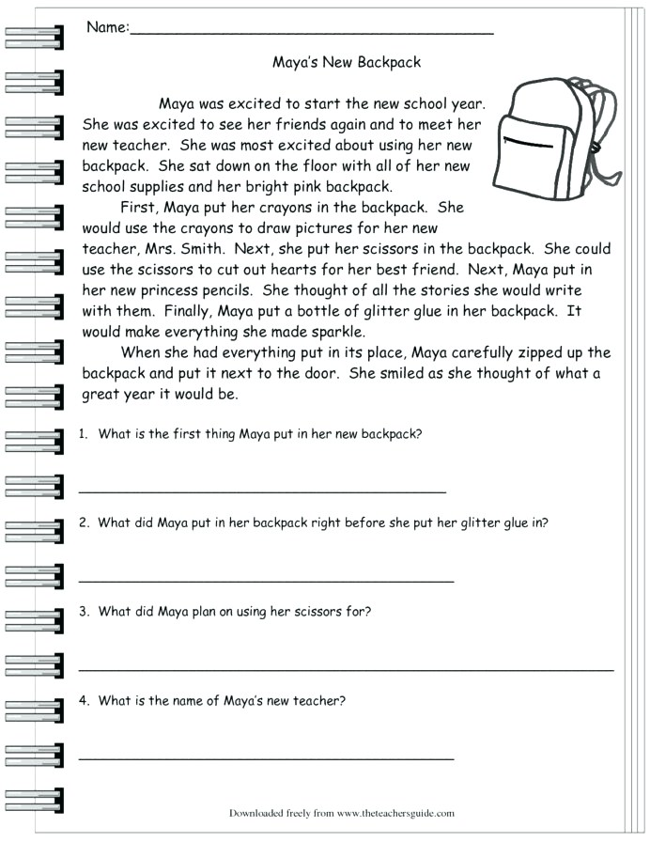

Name:_________________________________
- Choose the correct answer:
1. What are you going.......... tomorrow?
A. to do B. do C. did D. doing
2. Linda..... going to visit her friends next weekend.
A. was B. is C. is D. B&C
3. They...... swimming last Saturday.
A. go B. going C. went D. goes
4. Are they going to the party tomorrow? - Yes, they.............
A. are B. do C. did D. can
5. He should go to the........... because he has a toothache.
A. dentist B. nurse C. teacher D. doctor
- Read the text and choose the correct answer
Yesterday.......... (1) a terribly cold day but Jim...... (2) out without warm clothes, so he...... (3) a bad fever. His mother took him to the doctor. The doctor gave him............... (4) aspirins and said " You should....... (5) warm clothes and you shouldn't go out. I think you will get better soon. "
1. A. was B. were C. is D. are
2. A. go B. going C. went D. goes
3. A. has B. have C. had D. having
4. A. an B. a C. any D. some
5. A. wear B. wore C. wearing D. to wear
- Write
1. going/ We/ to/ are/ Do Son/ next weekend/ visit.
.....................................................................................
2. you/ going/ Are/ T.V/ watch/ to/ this evening?
.....................................................................................
3. visit/ going/ She/ is/ her/ tomorrow/ friends/ to.
.....................................................................................
- Read and answer the questions:
Last Sunday, Lan didn't go to school, but she went to her friend's birthday party. She got up early in the morning, went to the shop, and bought some gifts and flowers. Then, she went to her friend's house. At the party, she ate a lot of cakes and drank soft drink. She danced beautifully, sang many songs, and told a lot of interesting stories. All her friends were there too. They played many games such as hide and seek, skipping rope and cards. They were very happy and enjoyed themselves a lot. Finally, the party came to an end. They said goodbye to each other and went home late in the the evening.
Questions:
1. Did Lan go to school yesterday?
.....................................................................................
2. Where did she go to?
.....................................................................................
3. What did she buy for her friend?
.....................................................................................
4. What did she do at the party?
.....................................................................................
5. Did they enjoy themselves a lot?
.....................................................................................
6. When did they go home?
.....................................................................................
Name:______________________________

1. The old woman __________ some cookies for her family yesterday.
- climbed
- baked
- ate
- cried
2. My childhood ________ happy and I would like to share about it.
- is
- are
- were
- was
3. We really___ the game last Sunday.
- enjoy
- enjoyed
- enjoied
- enjoyyed
4. CHOOSE THE CORRECT VERB:
She _________ her bike, yesterday.
- ride
- drive
- rode
- rided
5. Which is a Past Expression?
- Every day
- Today
- Last week
- This week
6.
I __________ (go) to Tsim Sha Tsui with my parents.
- go
- goes
- went
- gone
7.
I __________ (have) a really good weekend.
- have
- has
- had
8.
I __________ (learn) a lot about science!
- learn
- learnt
- learns
9.
They __________ (be) very interesting.
- is
- was
- are
- were
10. Which Irregular verb correctly answers the sentence?
The goalie quickly ________________ the ball that was kicked towards him.
- Thought
- Lit
- Caught
- Fought
11. Which Irregular verb correctly answers the sentence?
After working all night long, Jonathan finally ____________ in bed once he had finished his work.
- Sleeped
- Slept
- Chose
- Ate
12. Which Irregular verb correctly answers the sentence?
Rebecca ____________________ all her paycheck money on lottery tickets, and now has no cash to pay for her apartment rent!
- Wasted
- Spent
- Spended
- Sought
13. Which Irregular verb correctly answers the sentence?
After losing the game, Brenda ____________ disappointed and annoyed.
- Lost
- Feel
- Feeled
- Felt
14. Red Riding Hood ________ her hair neatly before walking to the forest.
- changed
- baked
- looked
- brushed
15. The giant ___________ down the beanstalk to catch Jack.
- jumped
- danced
- climbed
- chased

Name:____________________________

Present Past Present Past

1. read 6. swim
2. sleep 7. go
3. climb 8. drink
4. write 9. study
5. buy 10. drive

Transfrom the sentences to simple past tense.

1. They watched a good film two days ago.
(-)
2. She didn’t eat her sandwich two hours ago.
(+)
3. I didn’t play basketball yesterday because it was cold
(+)
4. Did he finish his homework?
(+)
5. The children wrote a letter last week.
(?)

Fill in the blanks with the given words in parenthesis.

1. My sister and I (help) our mother yesterday.
2. I (clean) my house last weekend.
3. My brother (not /wash) his car last week
4. We (play) football last Saturday.
5. They (not/watch) TV last night.
6. The children (read) a book in dormitory yesterday.
7. She (not /study) English last night.
8. He (sleep) two hours yesterday.
9. Fatih (drink) an apple juice at lunch yesterday.
10. My brother (not /do) his homework after dinner last night.

CHOOSE THE BEST ANSWER

1. Did you .......... to the cinema?
went go
going to go

2. When did little Tom ........ the milk?
drink drank
drunk to drink
3. When did Mr. Smith ...... to London?
go went
gone to go

4. Where ...... you go yesterday?
do does
did went

5. ...... she ...... the tennis match?
Did/win Did/won
Does/win Does/won

6. She ..... ..... to the cinema
not went didn’t went
didn’t go doesn’t went

7. We ..... ..... in the morning
don’t come
didn’t come
came not
not came
8. We ..... the football match
didn’t win didn’t won
don’t win don’t won

9. What .... they .... in London?
did/see do/saw
did/saw do/see

10. When .... you .... to Madrid?
did/go did/went
do/go do/went

11. They ........... to school yesterday
didn’t came don’t come
didn’t come don’t came

THE END

